CSA1411-COMPILER DESIGN

LAB EXPERIMENTS

NAME:- R KALAI AMUDHAN

REG NO:- 192511292

EXPERIMENT – 11:
AIM:-
Implement a C program to perform symbol table operations.
CODE:-
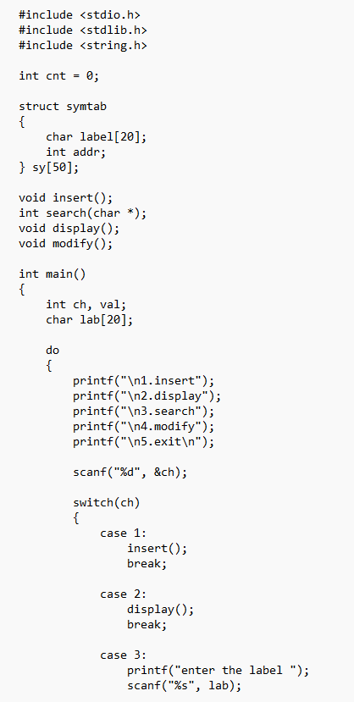
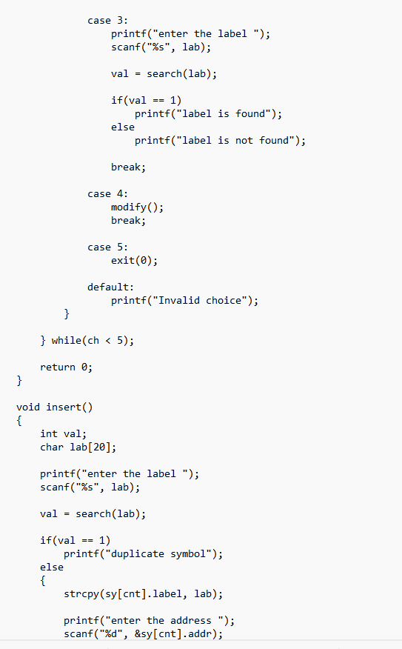
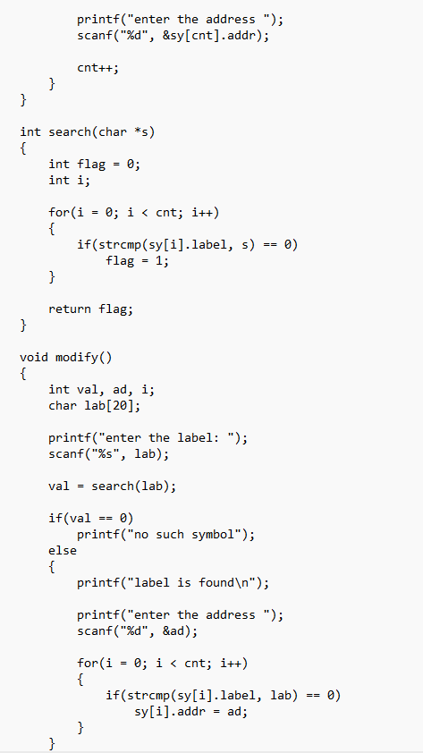

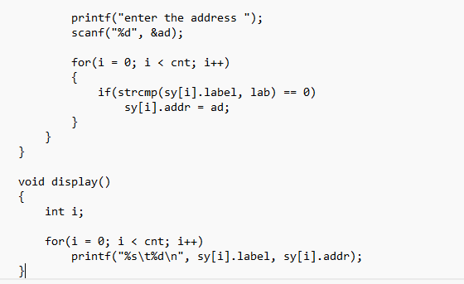
OUTPUT:-
